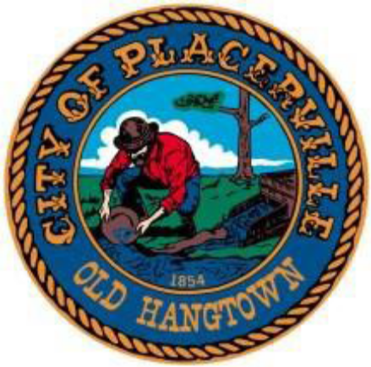
549 Main St. Placerville, CA 95667
(530) 642-5232

NOTICE OF CANCELLATION

The City of Placerville Regular Recreation and Parks Commission
Meeting on November 17, 2025 is hereby canceled.

The next regular meeting of the Recreation and Parks Commission
is scheduled for Monday, December 15, 2025 at 5:00 P.M.

